**Night Vision Goggles NORTIS 7G(W)**

NORTIS 7G(W) is based on the latest optelectronics technology. It uses high-performance second-generation/third-generation image intensifier. It features excellent performance, small size, light weight, clear imaging, video output, adjustable eye distance, and can change magnification by changing objective lenses (or connecting multiplier lenses). This product can be adjusted arbitrarily with different eye distance requirements. Built-in red explosion lamp, infrared lighting and automatic strong light protection. This product has strong practicability and can be applied to military observation, frontier and coastal defense reconnaissance, public security surveillance, evidence collection, customs smuggling, etc. in the night without lighting. It is an ideal equipment for public security departments, armed police forces, special police forces, and guard patrols.

4 switch position: OFF, ON, IR(on), AUTO; Auto gate function; Flip up auto shut off function;

|  |  |
| --- | --- |
| **SPECIFICATIONS** | |
| **Magnification** | **X1** |
| Field of View | 42° +/-2 |
| Range of Focus | 25 Cm to infinity |
| Diopter Adjustment | +5 to -5 |
| Battery Type | 1x CR123 |
| Battery Life | Min. 60 hours |
| Operating Temp. | -40°C to +50°C |
| Dimensions WxHxL (mm) | 130x130x69 |
| Weight (gr.) | 393 ex. battery |

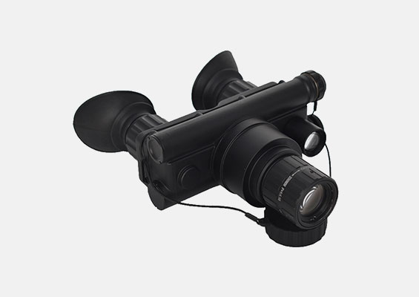

Features:

/ IP65 (IP67 optional) waterproof

/ Bright source protection

/ Mil-spec multi-coated optic

/ Automatic brightness control

/ Fully adjustable head mount

/ Automatic shut off when flip up

/ No power consumption when in standby

/ Helmet mount