Night Vision Goggles NORTIS 31G(W)

The NORTIS 31G(W) is a high-performance military head mounted night vision binocular with reference to pvs-31, an active head mounted night vision binocular in the United States. Low light NORTIS 31G(W) has the characteristics of super large field of view, high definition, no distortion, light weight, high strength (the overall performance is much better than the original version of the U.S. military products), which is the ideal choice for military night equipment.
4 switch position: OFF, ON, IR(on), AUTO; Auto gate function; Flip side auto shut off function;
SPECIFICATIONS
Magnification | X1
Field of View | 42° +/-2
Range of Focus | 25 Cm to infinity
Diopter Adjustment | +5 to -5
Battery Type | 1x CR123
Battery Life | Min. 40 hours
Operating Temp. | -40°C to +50°C
Dimensions WxHxL (mm) | 115x175x58
Weight (gr.) | Max.488 ex. battery

Features:
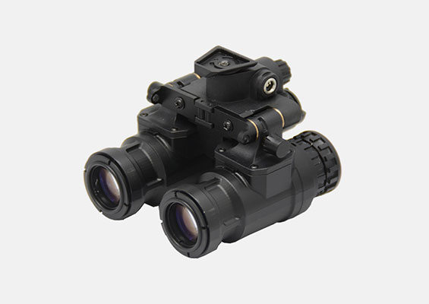
/ IP65 (IP67 optional) waterproof
/ Low battery indication
/ Bright source protection
/ Mil-spec multi-coated optic
/ Automatic brightness control
/ Fully adjustable head mount
/ Automatic shut off when flipped side
/ No power consumption when in standby
/ Large IPD range
/ Helmet mount

